

Low residuals means less error

We use residual analysis because
- R² is limited, may not guarantee, even if R² is higher
- Residuals could give and idea of a pattern or trend

Types of residual analysis to validate regression analysis
- Normality of residuals
- Randomness of order
- Constant variance

1. Normality of residuals
Uses a normal probability plot graph to analyze.
Based on the assumption that errors follow a normal distribution

2. Randomness of order
Uses a graph that plots residual vrs the order they are observed
Based on the assumptions that errors are random and independent and ar no affected by the order in which data is collected

3. Constant variance
Plots the residuals vrs the fitted values to identify unusual patterns
Based on the assumption that errors have constant variance over all values of x

1. Normality of residuals

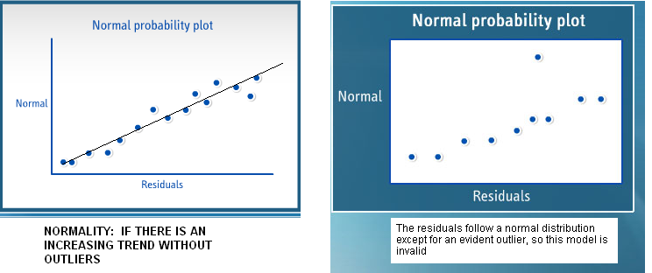

2. Randomness of order

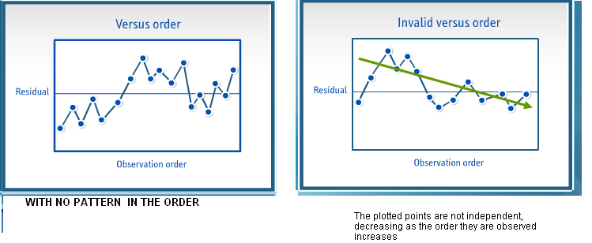

3. Constant variance

